The dashboard for the Grazioso Salvare company will display the full database for the Animal shelter database with certain functionalities. For one it is limited to 15 entries per a page with every other line being shaded in order to increase readability. Below each column header there is a box in order to type a filter for the specific column type and therefore filter your information based on what is typed. There are also arrows next to each column header in order to filter the results of the database in a sorted order based on the column it is selected from. All of this is to increase user ease in navigating the platform. In addition to this, you are able to click the radio button on the left in order to select a row and therefore show the geolocation on a map of where that animal was rescued from. There is also a pie chart on the left of this geolocation map that will display the different breeds of animals and their numbers.

*Pictures of the unfiltered database listing are shown below.*

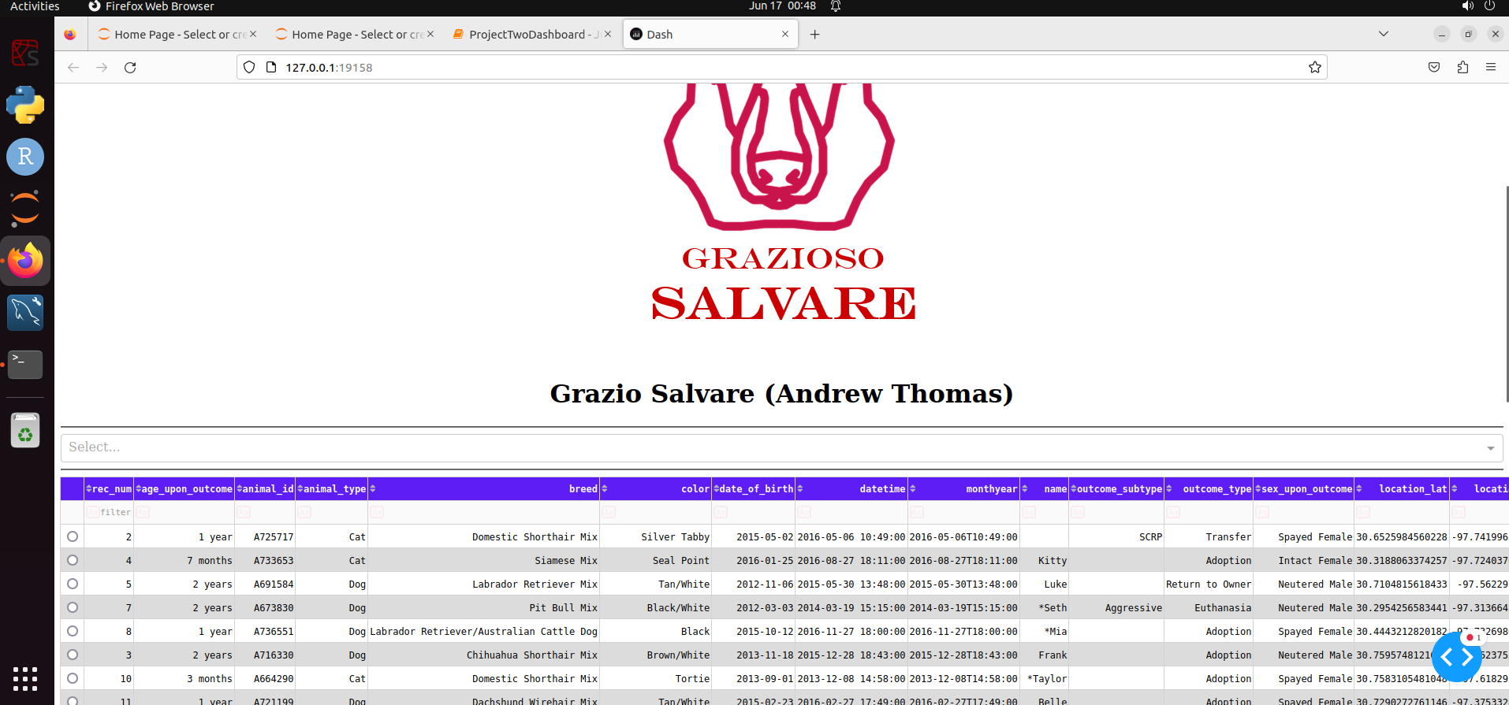

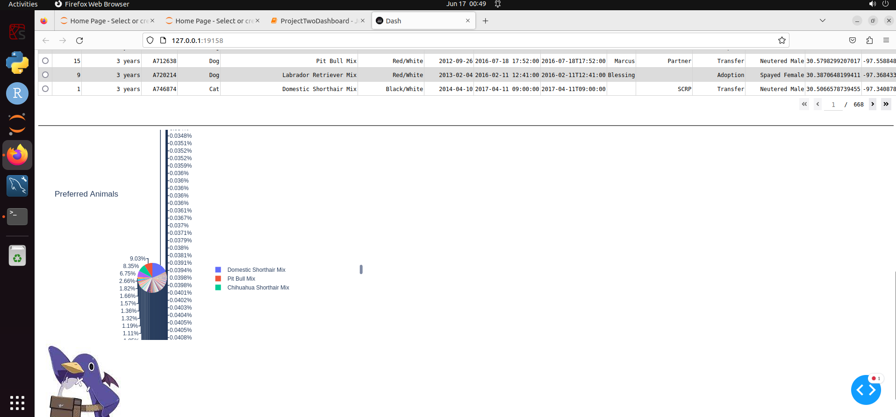

Above the columns of the data, there is a drop down box which will show the different filters in order to filter the database based on certain criteria that are preferred for particular rescue training. Selecting any of these filters will change the database to show the information that is relevant to the requirements of each selection. By choosing reset, you can return the database back to its raw unfiltered state. The pie chart mentioned previously will change to reference the data that is filtered and therefore show you the number of the breeds that are contained in the database pertaining to that particular filter.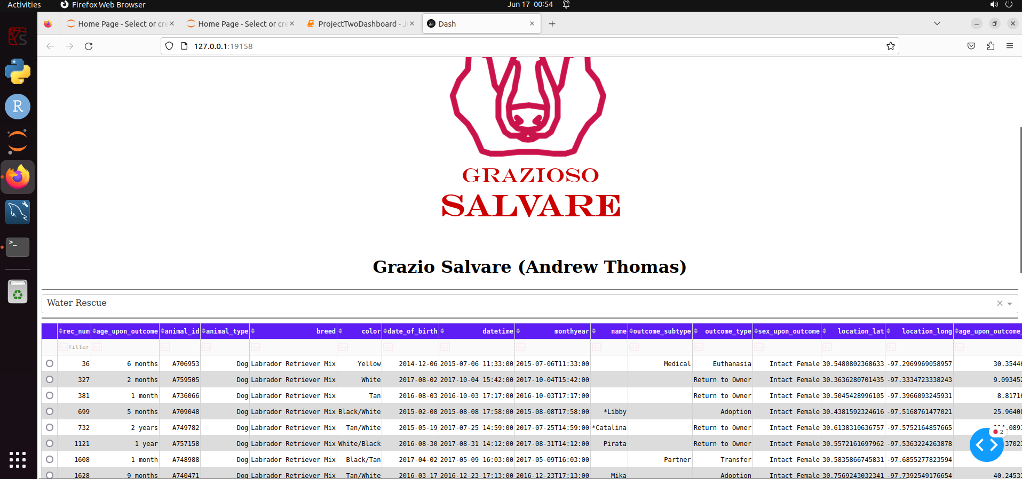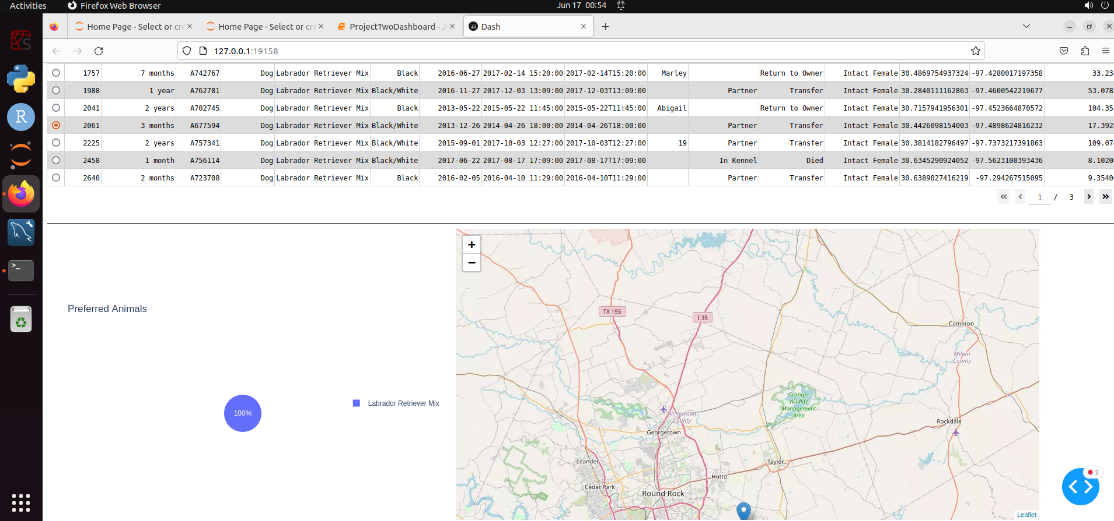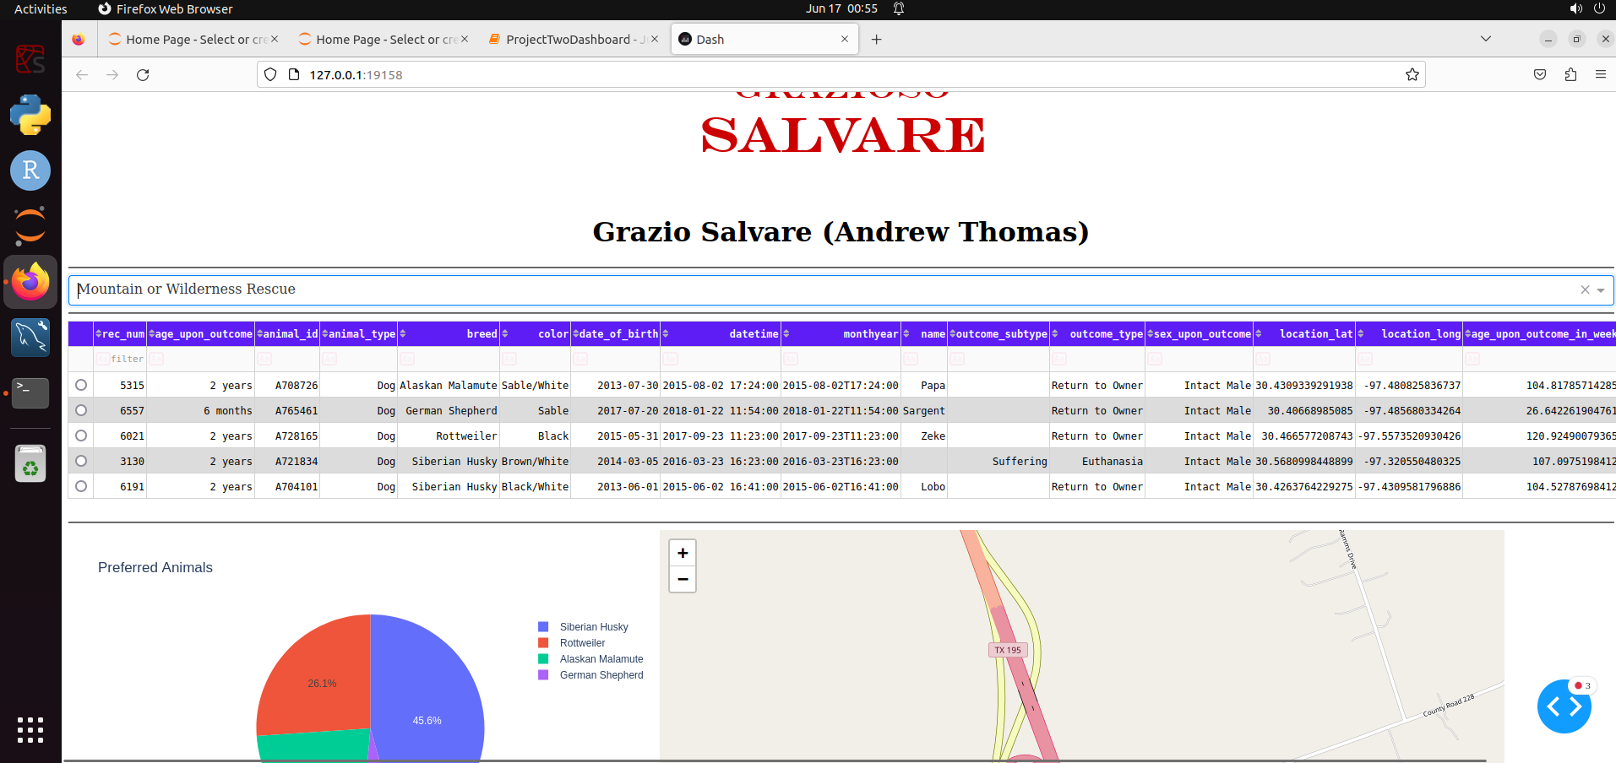

*Examples of each filter in use is shown down below.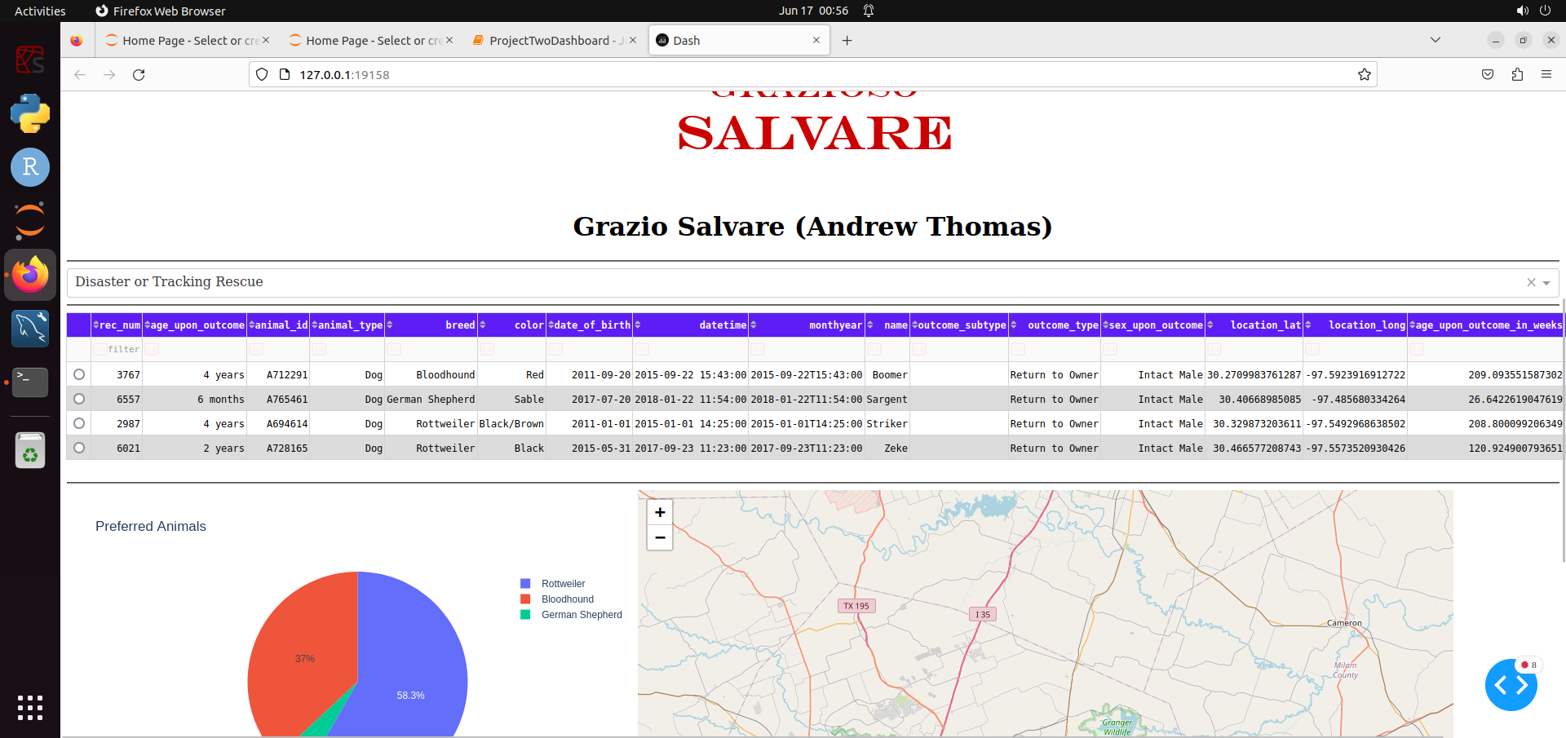*

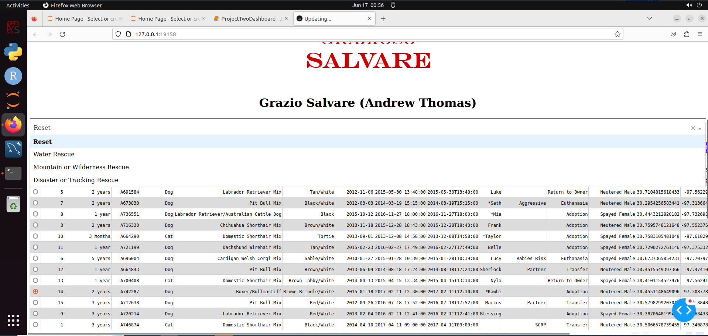

This functionality was achieved by using a combination of a python script, a mongo database, and a dash framework. The python script allowed for an easy method to access the database after it was established. By using the script in order to create an object of database access, using a username and password. It allowed us to access the database to perform the functions of Creating, reading, updating, and deleting the database entries. By using this script it allowed the functionality to allow the dash framework to connect to the database and perform these functions for us rather than having to type every single option into the database. The dash framework allowed us a more easily user friendly way to access and manipulate the data. By using the framework to create the application. It gave us a more pleasing and easily used form of access to the database. It also created easy functionality in order to plot and view data in different ways.

It uses a method of parsing out all of the different elements of the dashboard into different sections that we can set up to reach out to small controllers later in the framework through a method of callbacks. By using these callbacks we can control the user input in order to provide the functionality we need. Such as when a user selects a row on the data table, it will reach out to the controller for the geo map and provide the information of that data row. Allowing for us to get the longitude and latitude of the rescue animals rescue location and show us exactly where on the map they are.

MongoDB was used as the database because it provides a functionality to store countless amounts of data in one document. This document could further include other documents that allow for ease in providing numerous bits of data in one place and allowing for you to further nest and filter that data in various ways that can be extremely useful. It gives you a large amount of control over how you can manipulate that data. And using it with the panda’s framework for the dash access makes it even easier. Such as the ability to actually drop whole columns of data (like the _id column that the dash framework wouldn’t be able to recognize the type of). This allows you great control over the data in order to clean it up.

The steps taken in this project started with loading the database and then learning how to access that database, from that point it came down to writing the python script in order to access the database and manipulate it via creating an object to reference into and connect to that database. From that point it moved into figuring out how to use this script with the dash framework. Once that was more or less figured out, it came down to designing a framework for relative ease of the user in order to take advantage of this script as a connection to the database in order to manipulate and use the data for the user’s ease.

A Big trouble I personally had was trying to get the pie chart to work properly. Nothing in the documentation actually made note that you needed to track the values by a numeric data type (at least that I saw). And thus I was trying to connect to the data through various string literal types of data and while it wasn’t throwing any errors, it wasn’t drawing any kind of chart. Once I was made abreast of that, it became a simple product of figuring out which datatype I could use to populate the chart while using the breed as the name type in order to sort the pie chart by the actual data I wanted to see.